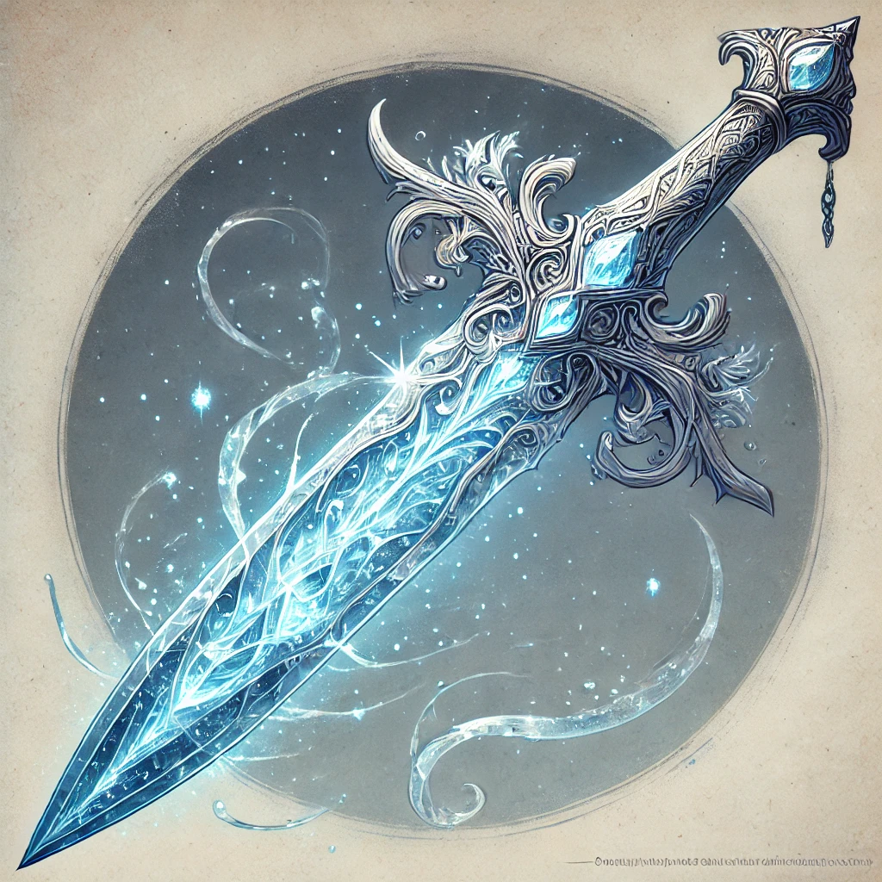
🔮 Frostbite Shard Dagger
(Rare, Requires Attunement by an Artificer)
Weapon (Dagger), Spell Focus, Arcane Firearm
This finely crafted dagger appears to be made of crystalline ice, never melting and always cold to the touch. The blade glows faintly with a blue arcane light, and when used as a spell focus, it channels powerful magic.
Properties:
- Damage: 1d4 piercing damage + 1d4 cold damage.
- Bonus to Attack Rolls: +1 to attack rolls made with this weapon.
- Spell Focus: This dagger can be used as a spellcasting focus for your artificer spells.
- Arcane Firearm: You can use this dagger as an Arcane Firearm for your level 5 Artillerist feature, allowing you to add 1d8 to one damage roll of any spell you cast through it. That damage will always be dealt as frost damage.
- Frostbite Infusion: When a creature takes damage from a spell you cast using this dagger as a focus, they take an additional +2 frost damage.

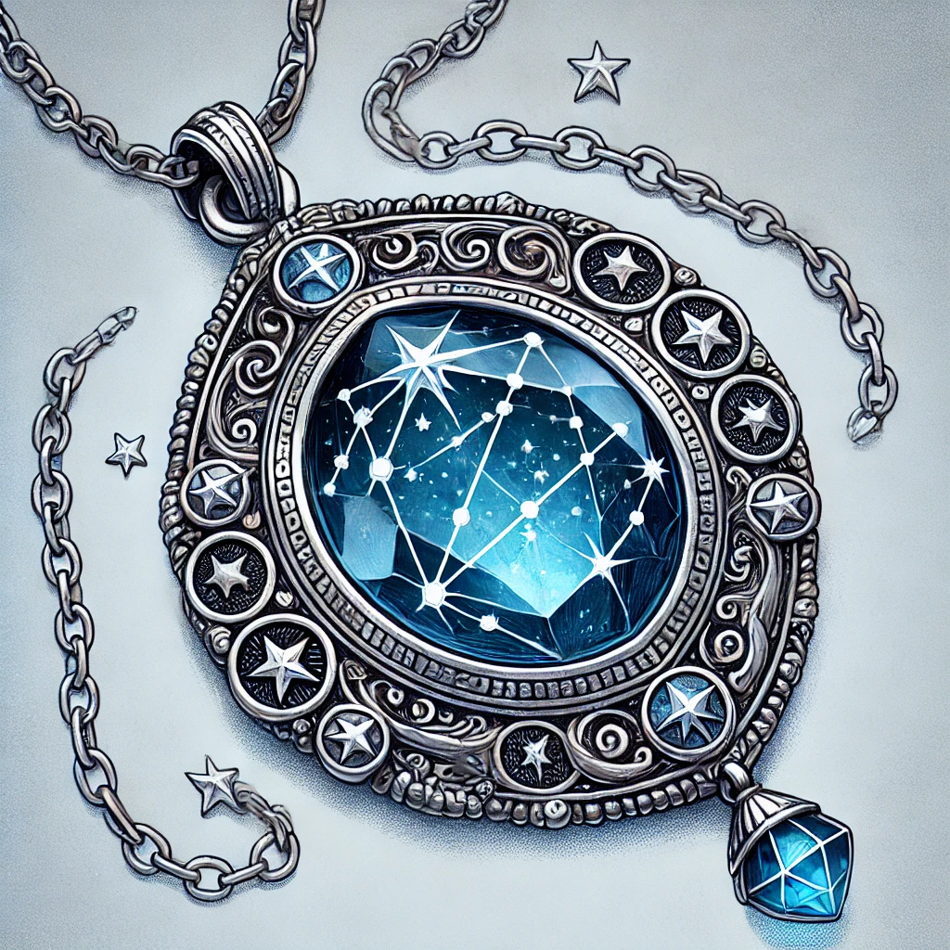
Amulet of Guiding Light
Wondrous Item (Requires Attunement by a Circle of Stars Druid)
This mystical amulet is crafted from polished silver in the shape of a radiant starburst, with intricate celestial patterns etched into its surface. At its center, a shimmering blue gemstone pulses softly, emanating a calming light reminiscent of distant stars.
While wearing this amulet, you gain the following benefits:
- Guiding Light: When you enter your Starry Form, the amulet’s gem flares brightly, casting light in a 30-foot radius and dim light for an additional 30 feet. For the duration of your Starry Form, you and any allies within the bright light gain a +1 bonus to attack rolls and saving throws.
- Starry Glow (Reaction): When you or an ally within 30 feet is hit by an attack, you can use your reaction to unleash a burst of radiant starlight. The attacker takes 2d8 radiant damage, and they must succeed on a DC 15 Constitution saving throw or be blinded until the end of their next turn. You can use this feature once per long rest.
- Celestial Resilience: The amulet’s connection to the stars grants you protection against misfortune. When you roll a natural 1 on an attack roll, ability check, or saving throw, you can reroll the die. You must use the new roll. You can use this feature twice per long rest.

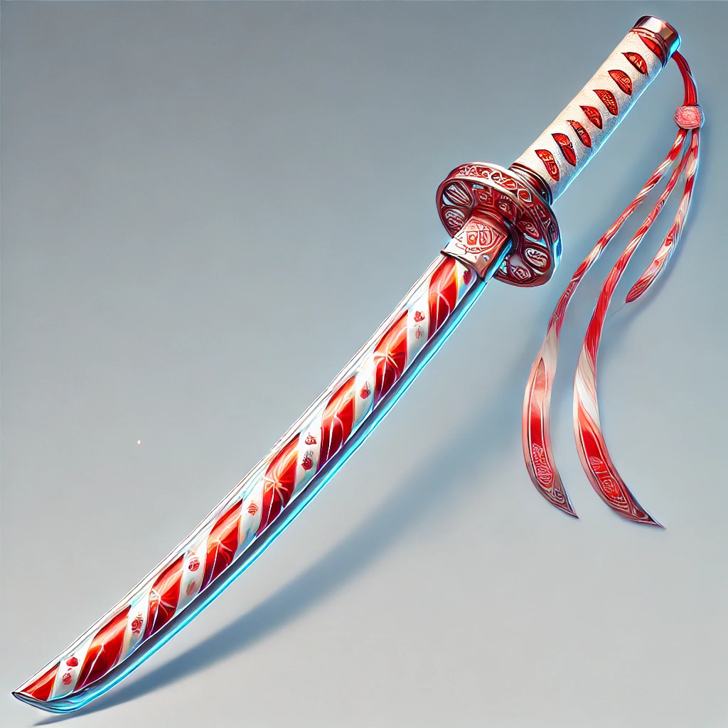
🍭 Candyfang Katana
Weapon (Versatile Katana), Rare (Requires Attunement by a Monk)
This finely crafted katana appears to be forged from a crystalline candy cane, its red and white stripes glimmering in the light. The blade is impossibly sharp, and a faint, sugary scent lingers around it. Despite its confectionery appearance, the weapon is deadly in combat.

Properties:
- Damage: 1d8 slashing damage (1d10 if wielded with two hands).
- Bonus to Attack and Damage Rolls: +1 to attack and damage rolls made with this weapon.
- Versatile: This weapon can be used with one or two hands.

Special Features:
- 🍬 Sugar Rush: Once per long rest, as a bonus action, you can lick the blade, gaining temporary hit points equal to 2d8 + your Constitution modifier. The sugary infusion energizes you, filling you with chaotic energy.
- ❄️ Frostbite Infusion: When you hit a creature with this weapon, you can choose to deal an additional +2 frost damage. The blade briefly flashes with a cold, crystalline sheen.

